**Linux Administration  
Lets Upgrade  
Assignement: 1**

|  |
| --- |
| **1. Create a blank file named "myfile"** |
| **2. Open "myfile" in vi editor** |
| **3. Write your name, address, email id, phone number and blood group in 5 different lines** |
| **4. Build one single expression to see the line with your name and blood group in myfile** |

**Question-1: Create a blank file named "myfile"**

**Ans:-**

**Command:-touch myfile**

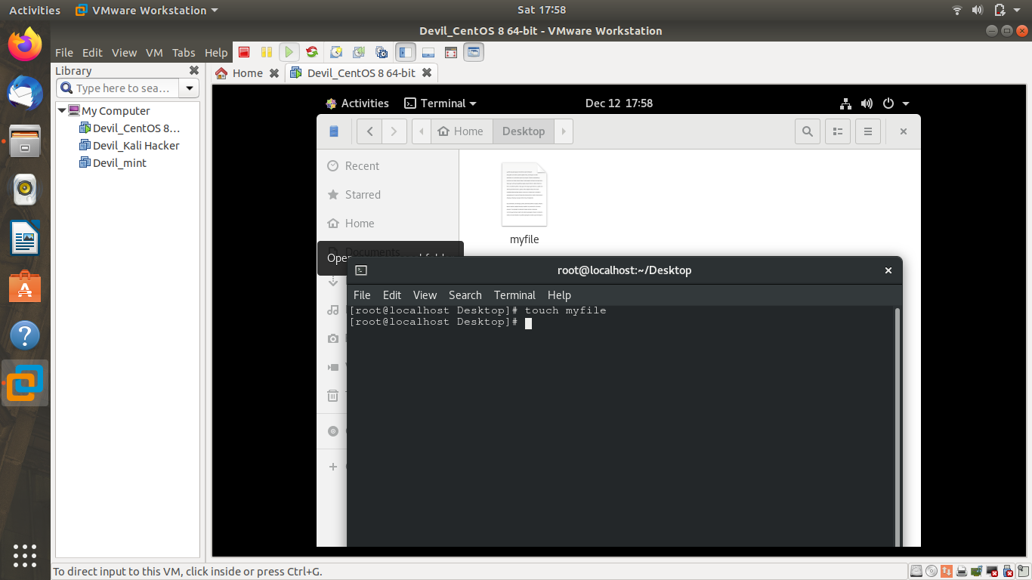

Question-2: Open "myfile" in vi editor

Ans: Command:- **vi myfile**

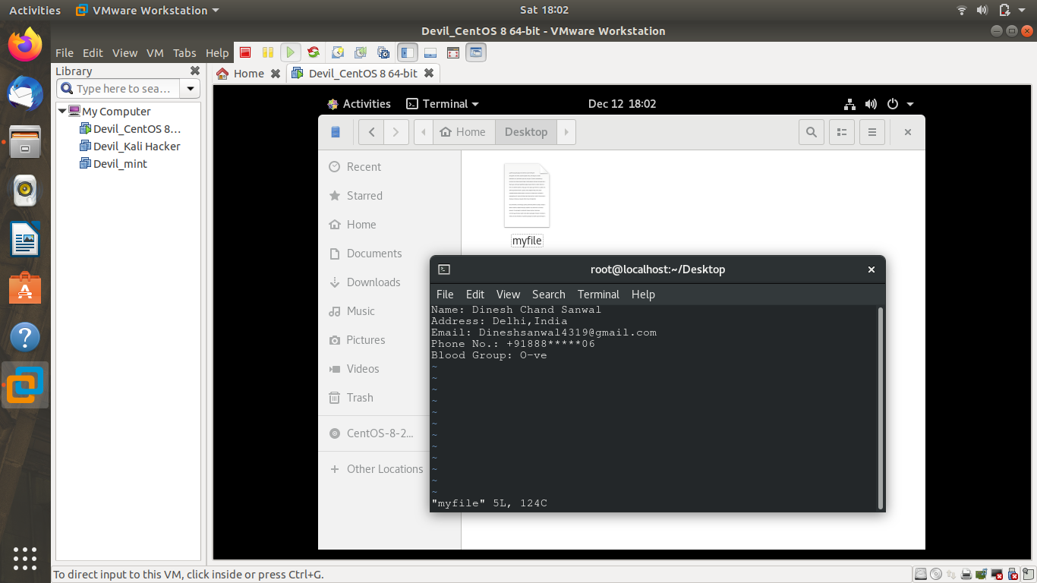

Question-3: Write your name, address, email id, phone number and blood group in 5 different lines

Ans:-

Commands:- **i 🡪** to insert

**Esc🡪**to exit from insert mode

**:wq🡪** to write and quit

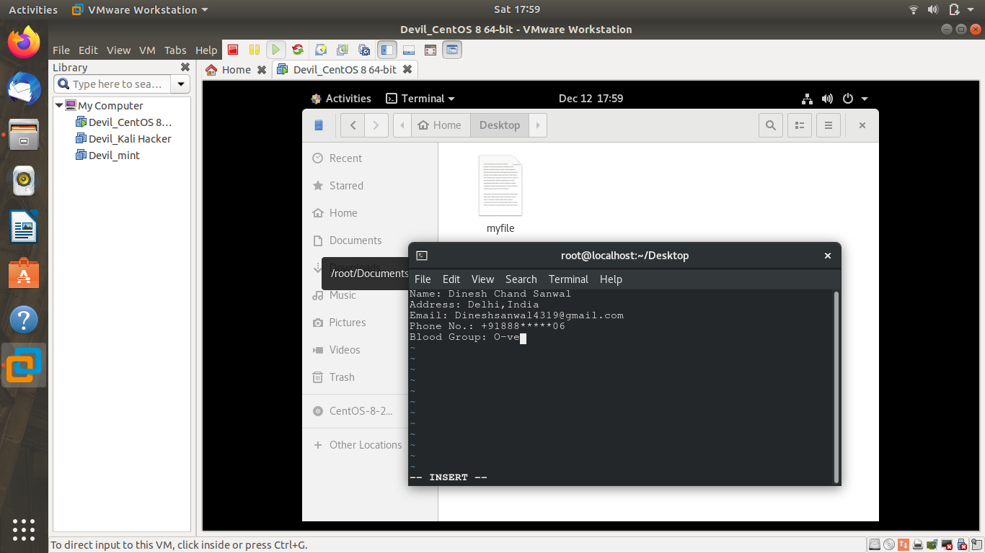

Question-4: Build one single expression to see the line with your name and blood group in myfile

Ans:-

Command:-grep -E 'Name|Blood' myfile

